#90days of DevOps :-

# day-10 :-
Task 1 :- output :-
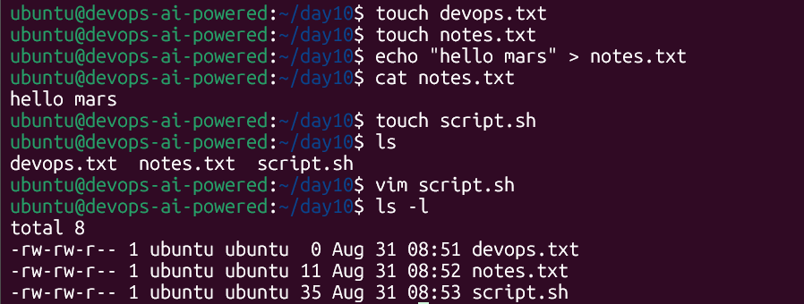
Task 2 :- output :-
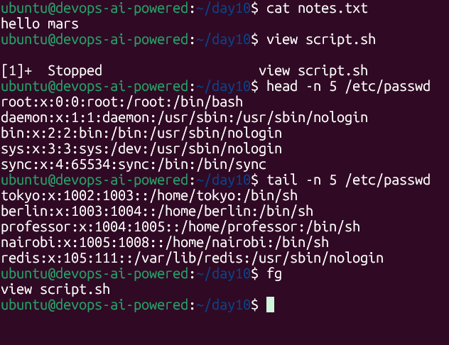
Task 3 output :-
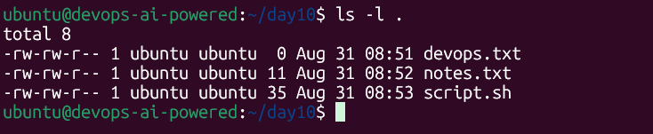

Devops.txt :- for this owner is allowed to read and write , same with group also but the other are only allowed to read only
Notes.txt :- for this owner is allowed to read and write , same with group also but the other are only allowed to read only
Script.sh :- for this owner is allowed to read and write , same with group also but the other are only allowed to read only

Task 4 output :-
ubuntu@devops-ai-powered:~/day10$ chmod 100 script.sh
ubuntu@devops-ai-powered:~/day10$ ls -l
total 8
-rw-rw-r-- 1 ubuntu ubuntu 0 Aug 31 08:51 devops.txt
-rw-rw-r-- 1 ubuntu ubuntu 11 Aug 31 08:52 notes.txt
---x------ 1 ubuntu ubuntu 35 Aug 31 08:53 script.sh
ubuntu@devops-ai-powered:~/day10$ ./script.sh
/bin/bash: ./script.sh: Permission denied
ubuntu@devops-ai-powered:~/day10$ sudo ./script.sh
Hello Devops
ubuntu@devops-ai-powered:~/day10$ chmod 400 devops.txt
ubuntu@devops-ai-powered:~/day10$ chmod 640 notes.txt
ubuntu@devops-ai-powered:~/day10$ mkdir project
ubuntu@devops-ai-powered:~/day10$ chmod 775 project/
ubuntu@devops-ai-powered:~/day10$ ls -l
total 12
-r-------- 1 ubuntu ubuntu 0 Aug 31 08:51 devops.txt
-rw-r----- 1 ubuntu ubuntu 11 Aug 31 08:52 notes.txt
drwxrwxr-x 2 ubuntu ubuntu 4096 Aug 31 09:31 project
---x------ 1 ubuntu ubuntu 35 Aug 31 08:53 script.sh
ubuntu@devops-ai-powered:~/day10$ chmod 700 script.sh
ubuntu@devops-ai-powered:~/day10$ ./script.sh
Hello Devops
ubuntu@devops-ai-powered:~/day10$ chmod 775 project/
ubuntu@devops-ai-powered:~/day10$ ls -l
total 12
-r-------- 1 ubuntu ubuntu 0 Aug 31 08:51 devops.txt
-rw-r----- 1 ubuntu ubuntu 11 Aug 31 08:52 notes.txt
drwxrwxr-x 2 ubuntu ubuntu 4096 Aug 31 09:31 project
-rwx------ 1 ubuntu ubuntu 35 Aug 31 08:53 script.sh
ubuntu@devops-ai-powered:~/day10$ echo "test" > devops.txt
-bash: devops.txt: Permission denied
ubuntu@devops-ai-powered:~/day10$ ./notes.txt
-bash: ./notes.txt: Permission denied
ubuntu@devops-ai-powered:~/day10$ chmod 755 project/
ubuntu@devops-ai-powered:~/day10$ ll
total 20
drwxrwxr-x 3 ubuntu ubuntu 4096 Aug 31 09:31 ./
drwxr-x--- 10 ubuntu devops-team 4096 Aug 31 09:20 ../
-r-------- 1 ubuntu ubuntu 0 Aug 31 08:51 devops.txt
-rw-r----- 1 ubuntu ubuntu 11 Aug 31 08:52 notes.txt
drwxr-xr-x 2 ubuntu ubuntu 4096 Aug 31 09:31 project/
-rwx------ 1 ubuntu ubuntu 35 Aug 31 08:53 script.sh*

